Name : Saurabh Sanjay Jadhav

Topic : Jenkins setup.

Assignment no. : 19

**Application Based installation**

1. Update the EC2 instance. Install Java in it.

Apt-get update

apt install openjdk-17-jre-headless

1. Install Jenkins.

sudo wget -O /etc/apt/keyrings/jenkins-keyring.asc \

https://pkg.jenkins.io/debian-stable/jenkins.io-2023.key

echo "deb [signed-by=/etc/apt/keyrings/jenkins-keyring.asc]" \

https://pkg.jenkins.io/debian-stable binary/ | sudo tee \

/etc/apt/sources.list.d/jenkins.list > /dev/null

sudo apt-get update

sudo apt-get install Jenkins

1. Connect to instance and open Jenkins in it. “<public-ip>:8080/Jenkins”

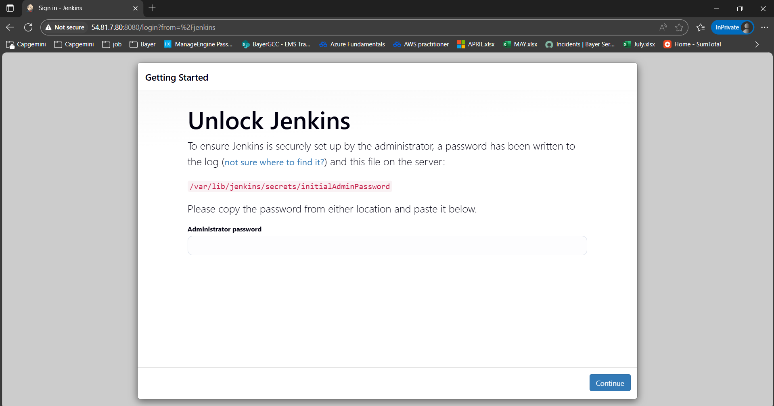

1. Get the administrator password from instance from below location.

Cat /var/lib/jenkins/secrets/initialAdminPassword

1. Homepage of Jenkins to install plugins.

1. Create admin user.

1. Homepage after login as user admin.

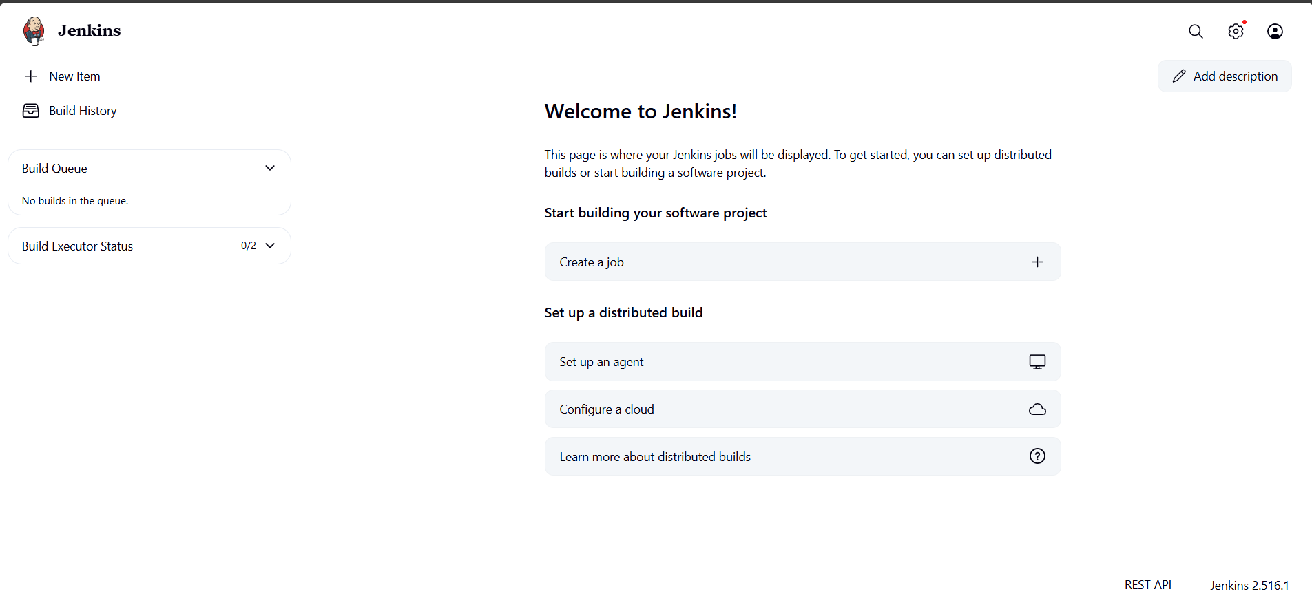

Service Based Installation

1. Update the instance and install java
2. Install tomcat

wget <https://downloads.apache.org/tomcat/tomcat-10/v10.1.44/bin/apache-tomcat-10.1.44.tar.gz>

sudo tar xzvf apache-tomcat-10.1.44.tar.gz -C /opt/tomcat --strip-components=1

sudo chown -R 777 /opt/tomcat

/opt/tomcat/bin/shutdown.sh

1. Install Jenkins in tomcat.

cd /opt/tomcat/webapps/

wget <https://get.jenkins.io/war-stable/2.516.1/jenkins.war>

java -jar jenkins.war

1. Hence successfully we can access Jenkins.

<public-ip>:8080

